**SIMPLE DJANGO BLOG**

**Home Page**

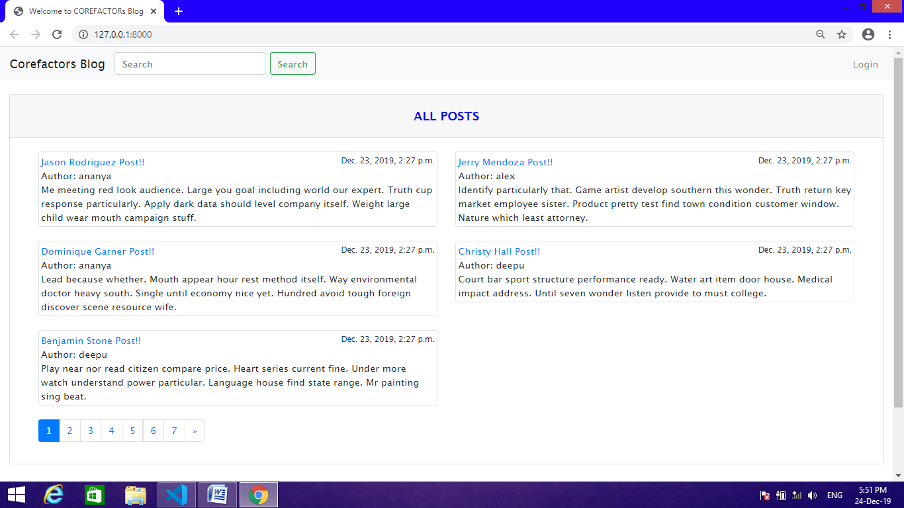Home page : User can see all posts in the blog, user can search blogs

**Post Detail**

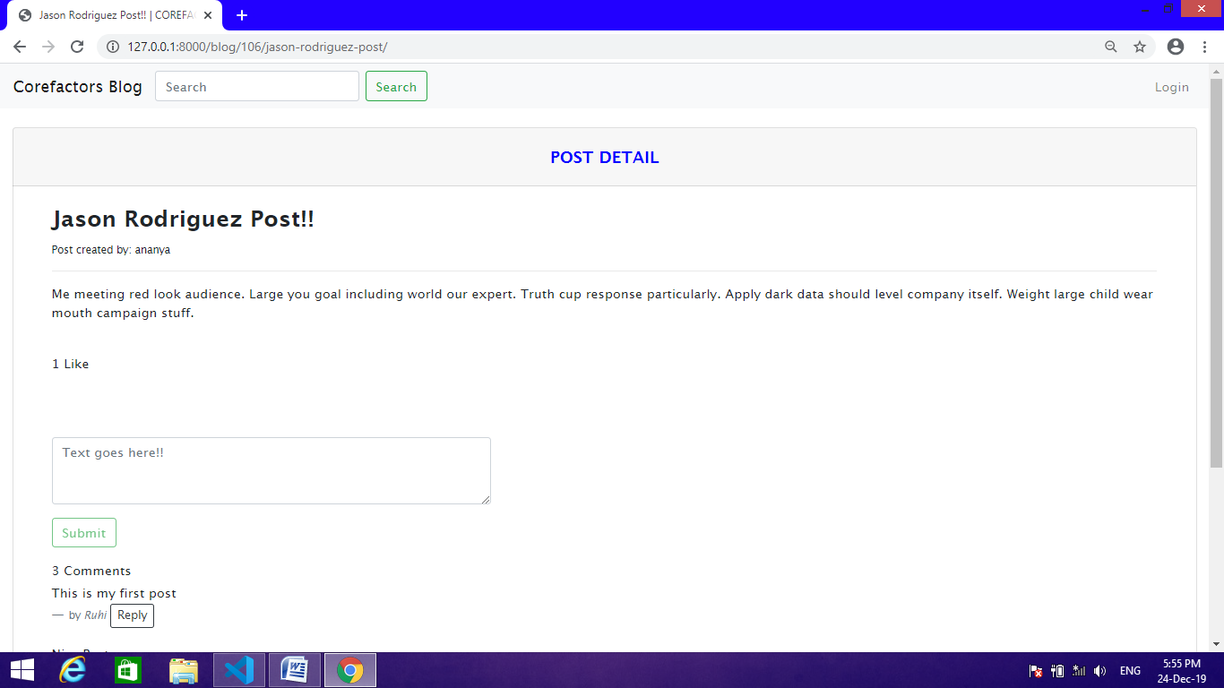

Post Detail Views For All Users : User can see all post but they can’t able like or dislike or comment on the post, they should login for comment or like.

**Registration Page**

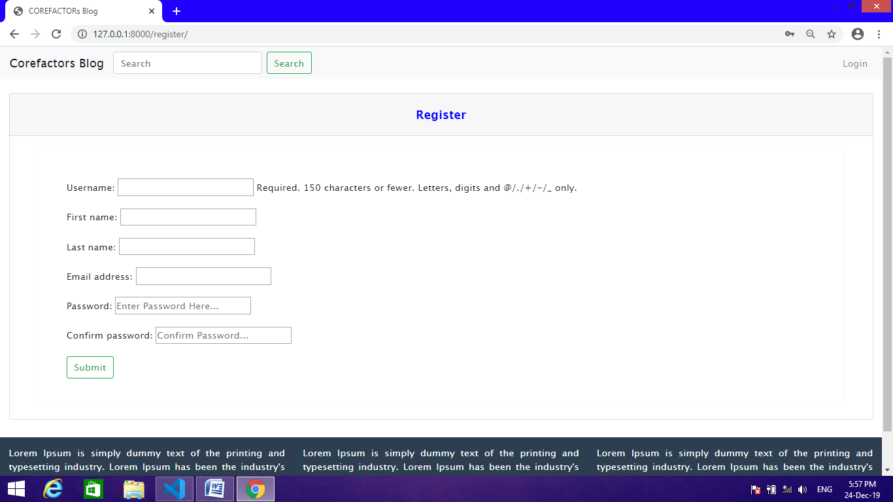

New User Registration : If user doesn’t have an account they can register.

**Login Page**

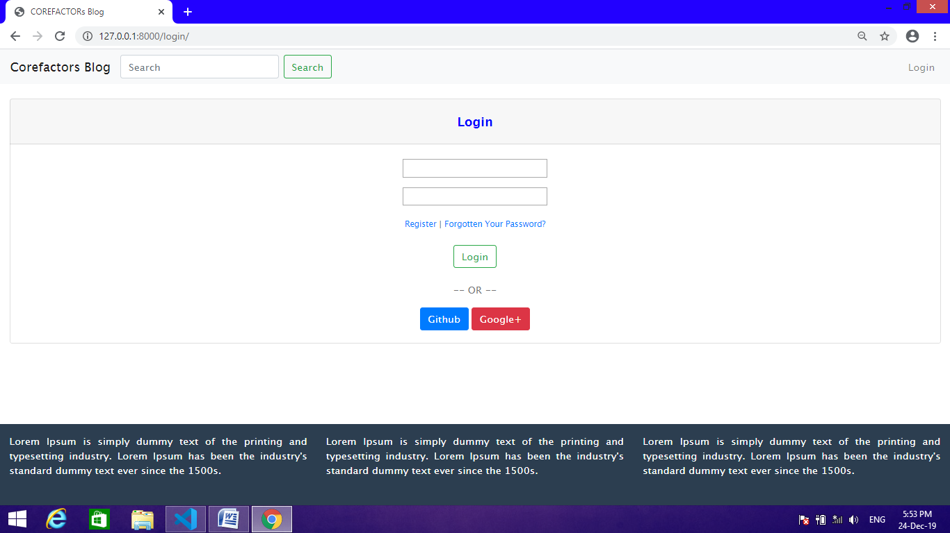

User Login:

Registered user can login

**Login View : DASHBOARD**

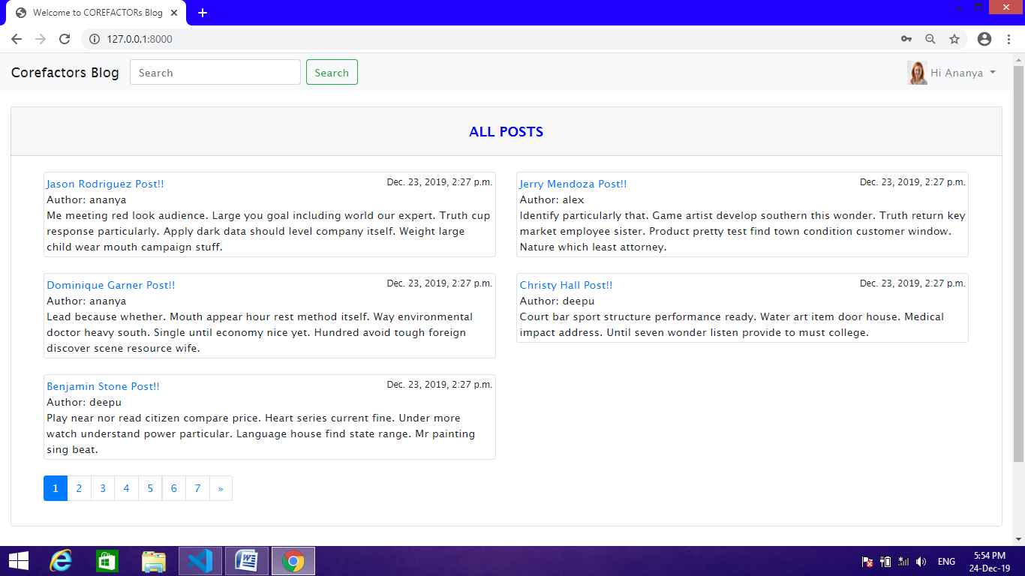

**Login View : Authorized user can login and can view all posts**

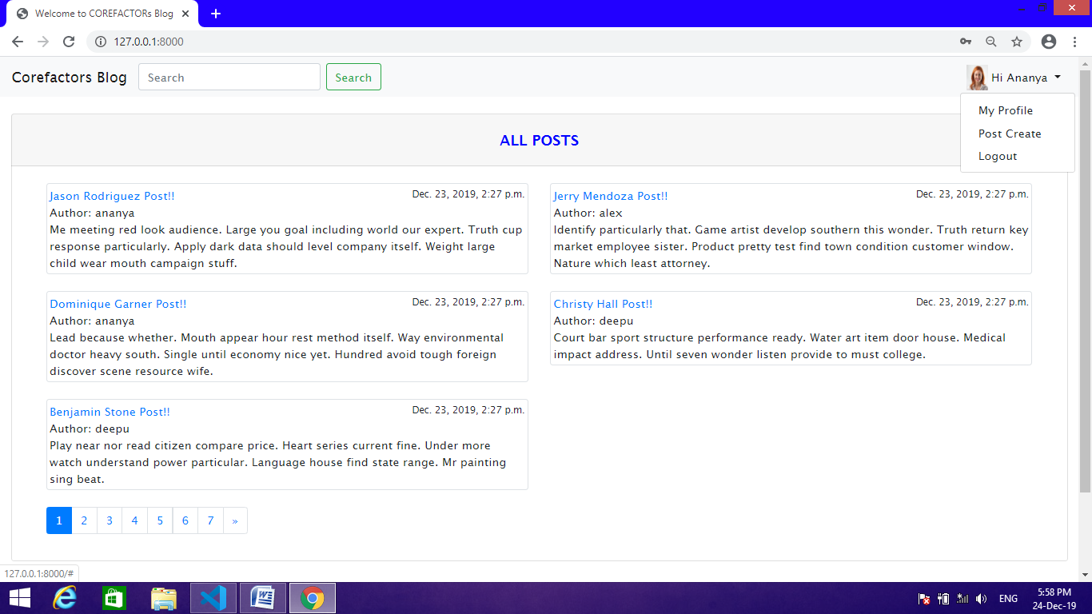

**Logged-in User Profile Edit:**

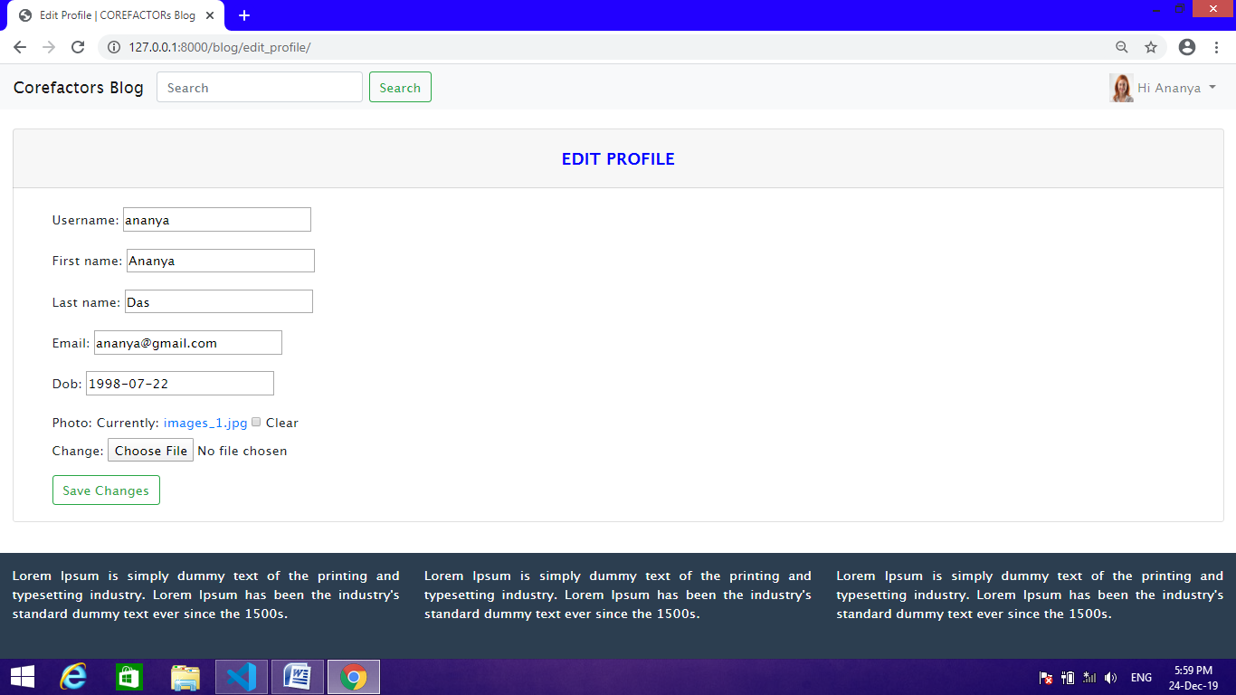

Logged-in user can edit their profile. They can update their profile details

**New Post Creation**

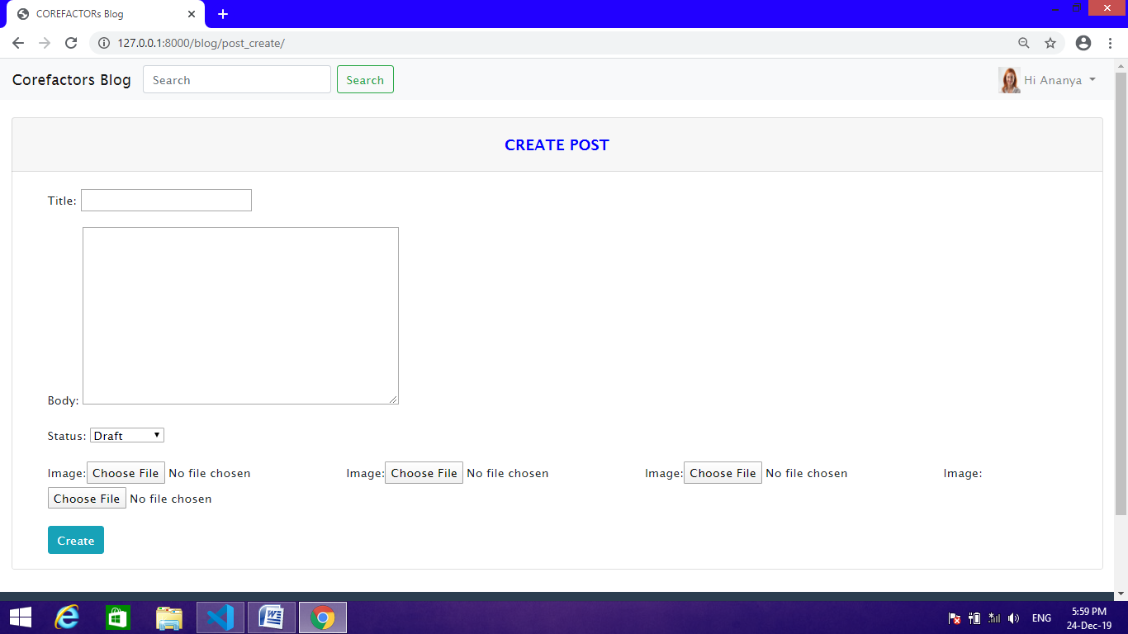

**LoggedIn User Post Detail View**

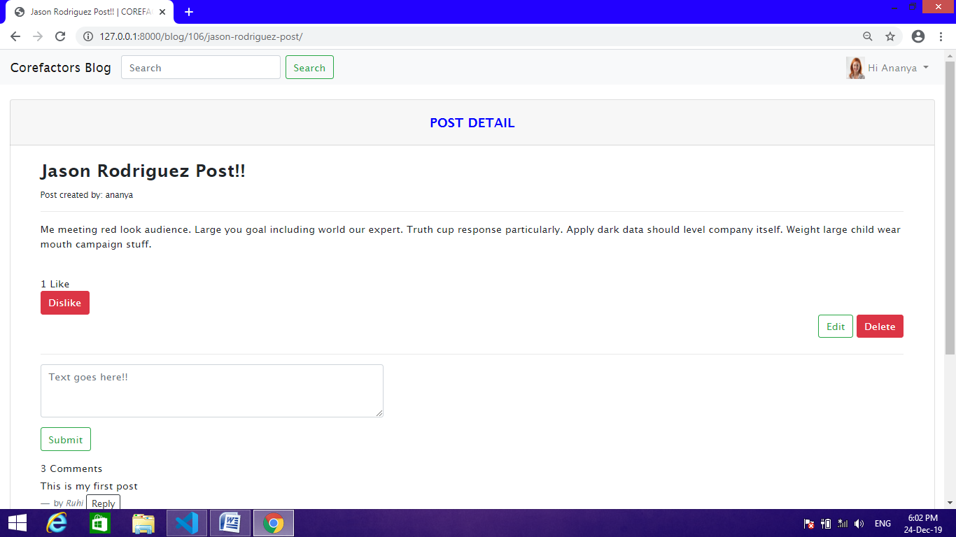

**Post Editing Page**

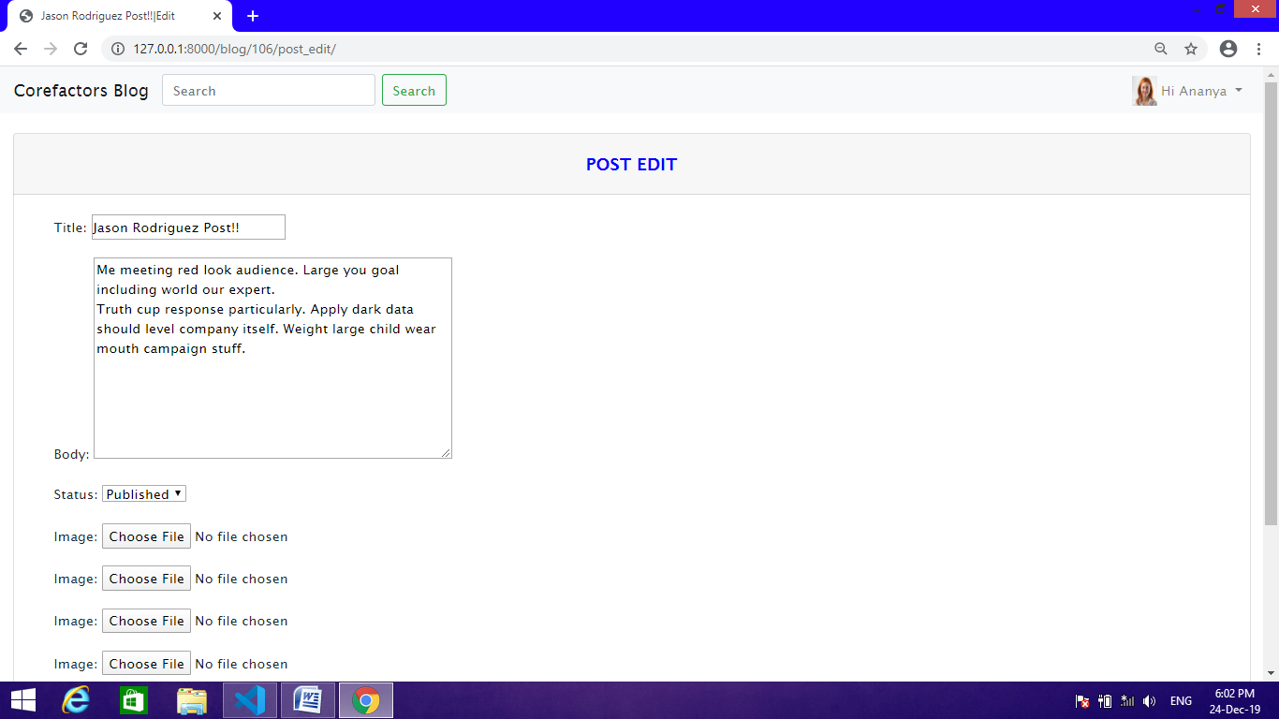

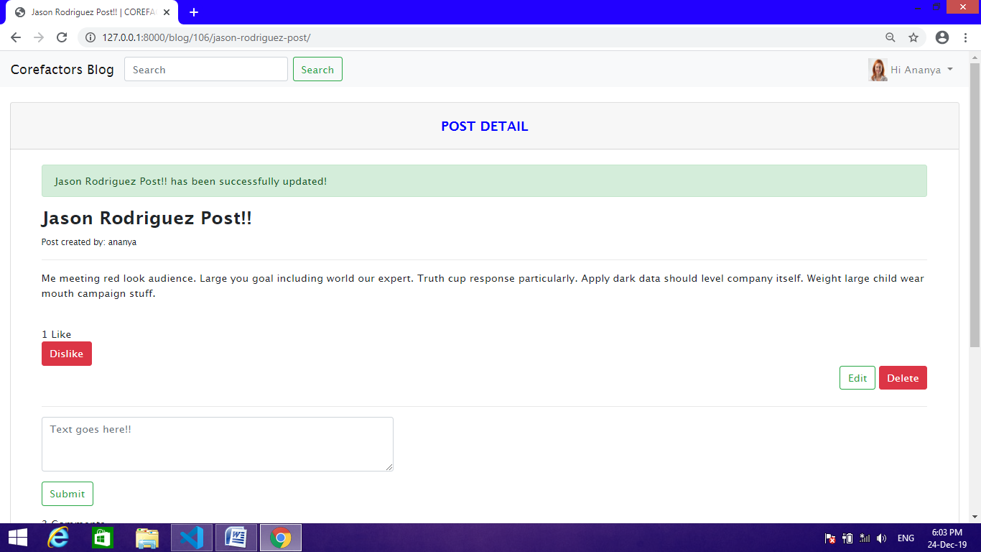

**Delete Posts**

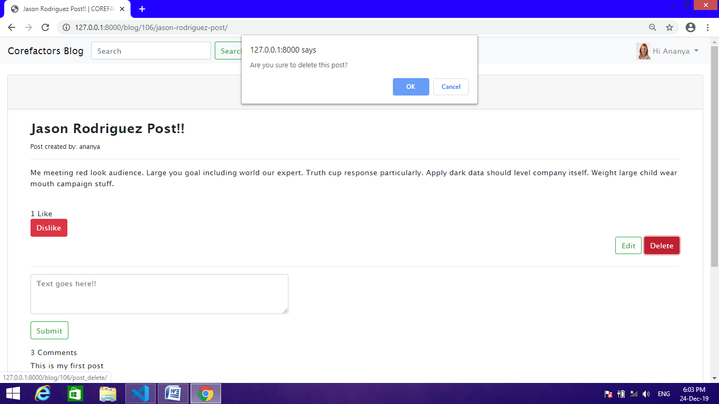

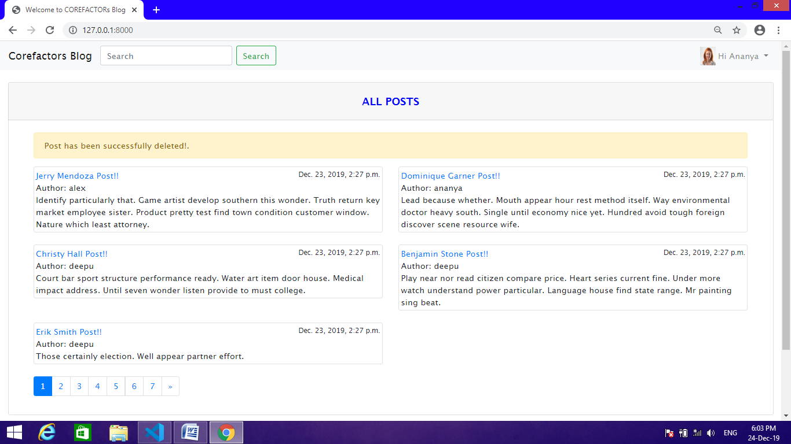

**Logged-in Users Uploaded Posts**

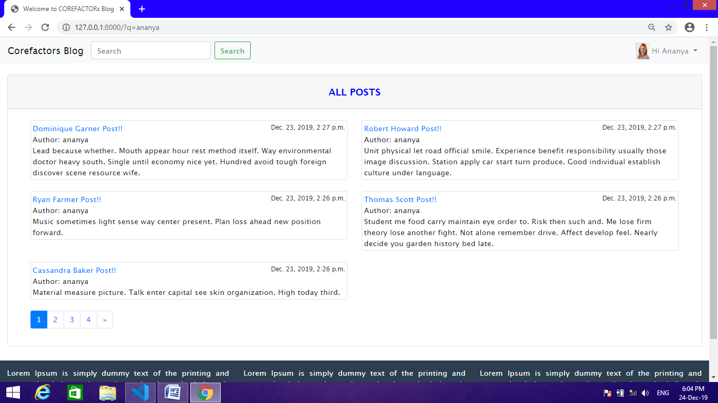

**Comment on others blog**

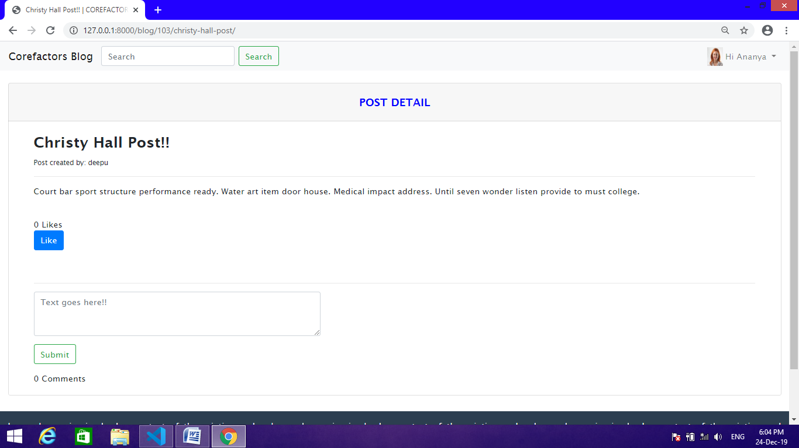

**Like or Dislike blogs**

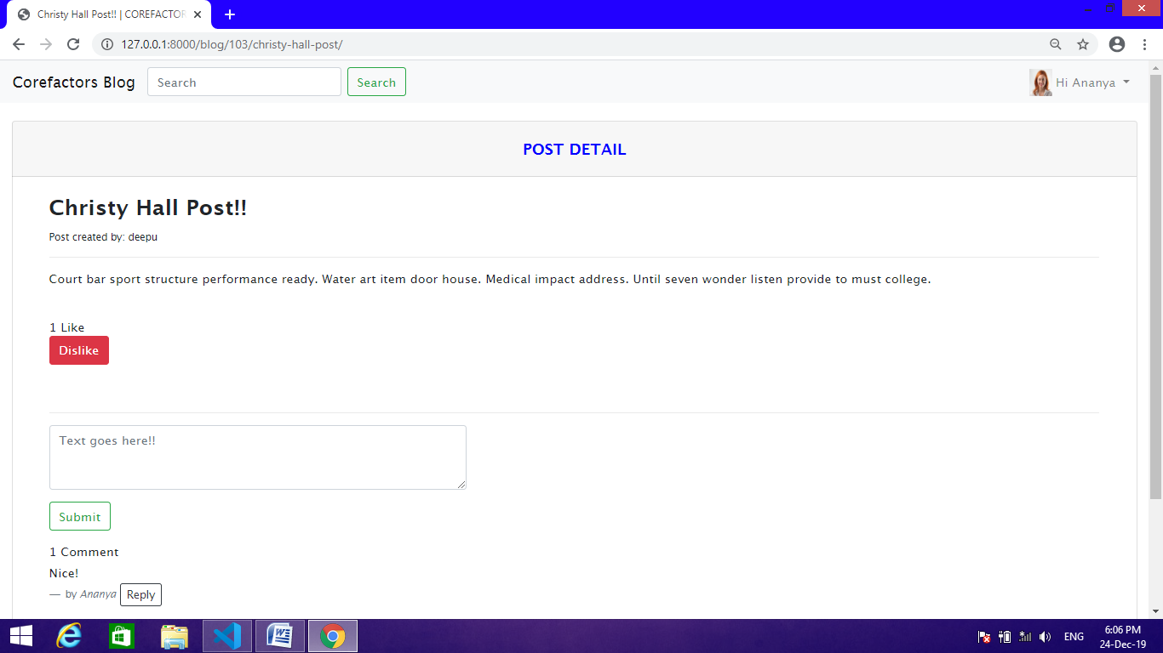

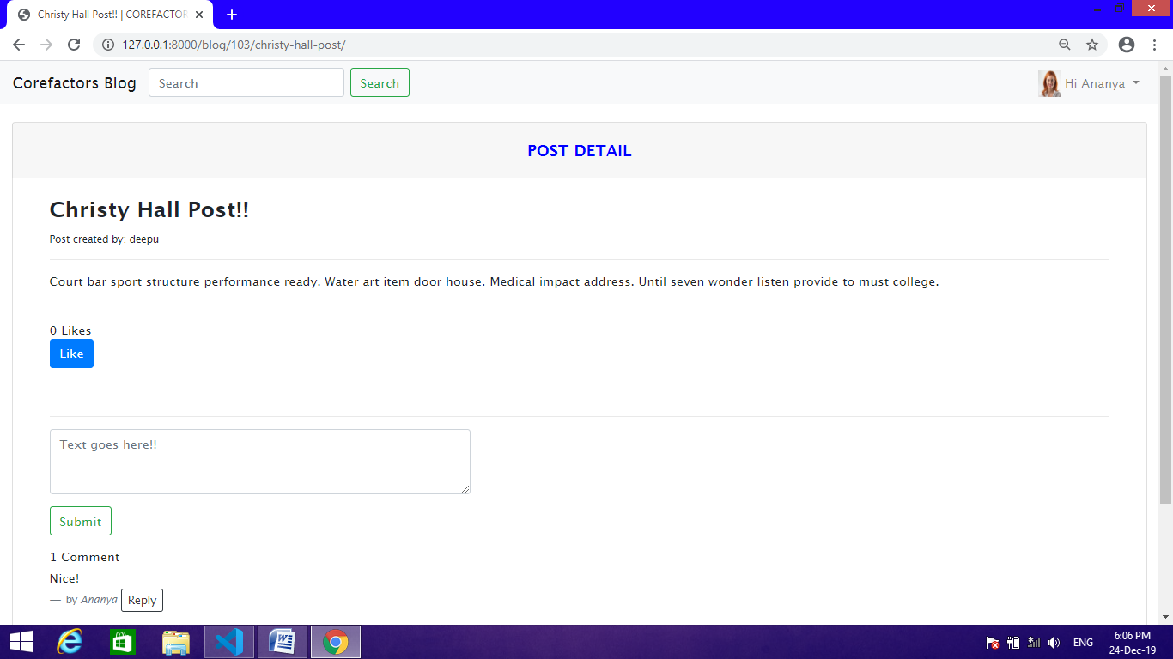

**Particular Blog View**

